Niagara Mist
Open Air Artisan Market

SPECIAL VENDING DISTRICT
The City of Niagara Falls is creating an open air artisan market along the
Rainbow Ramp. The “Niagara Mist Open Air Artisan Market” will offer vendors
the opportunity to sell various items in the downtown business district core.
The City will offer approximately 50 spots for vendors to set up tents along
Niagara Street beginning at Rainbow Blvd up to Third Street from
May 1st to September 30th.
This special vending district will offer tourists and residents an outdoor
market shopping experience of new products which will include jewelry,
pottery, clothing, housewares, art, collectibles, crafts by local artists,
leather goods and much more.

APPLY TO BECOME A VENDOR
To apply for vendor spots in this special vending district please fill out the
Vendor License Application which includes a complete description of what
you would like to sell and up to three photos of the merchandise.

LICENSE PERIOD, COMMITMENT & FEES
Your License will be issued for May 1 to Sept 30thof the current year of
your application. You will be required to vend by the posted hours on your
stall. Maximum open hours are 9AM till 11PM.
The vending fee for the season is as follows: (cash, business check, credit card)
10x10 space for the season is $1500.00 Location: Niagara Street -
(Rainbow Blvd up to Third Street)
The vendor stall must be a white tent 10X10.
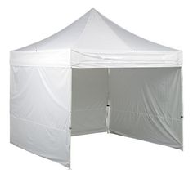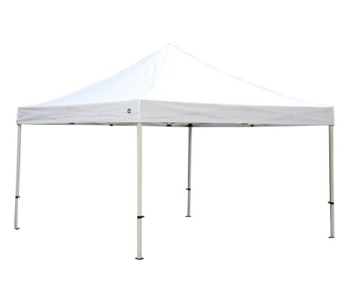

Vendor stalls must be executed in a professional manner using methods
of good craftsmanship.

HOW TO APPLY FOR A VENDOR STALL
- Fill out the application form
- Provide 1-3 pictures of the merchandise you wish to sell and of tent
- Provide Police Record background check from NFPD
- Provide NYS Sales Tax Certificate
- Provide Insurance Certificate General Product & Liability naming the City of NF as additionally insured
- Submit the application to the Office of the City Clerk

You will receive a written notice that your application has been approved
or denied. Upon approval your vending space will be assigned to you
by the Niagara Falls City Clerk’s Office.

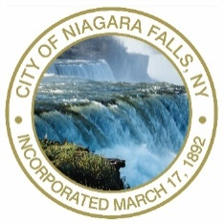
APPLICATION FORM
Niagara Mist Open Air Artisan Market

Name:_______________________________________________________

Business Name:________________________________________________

Address:_____________________________________________________

City:_________________________ State:____________ Zip:__________

Phone number: Home:_______________ Cell:__________________

Email: _______________________________________________________

Description of Merchandise: ______________________________________

_____________________________________________________________

_____________________________________________________________

_____________________________________________________________

_____________________________________________________________
Attachments:

______ Valid Photo ID

______ Photos of Merchandise and 10x10 Tent

______ Police Background/Record Check from NFPD

______ NYS Sales Tax Certificate

______ Insurance Certificate naming the City of Niagara Falls as as additional insured (General & Product Liability $1,000,000.00 per occurance & $2,000,000.00 per aggregate)

Conditions of Vending at the Niagara Mist Open Air
Artisan Market.

- I will provide the City of Niagara Falls with an insurance certificate.
($1,000,000.00 per occurance & $2,000,000.00 per aggregate)
- I will display my license at all times.
- I agree to pay the vending fee no later than April 30 ,2018.
- I will comply with all tent requirements.
- I understand that no property rights are created by the
maintenance of the vending area.
- I understand that there is no electricity at the vending site.
- I understand that the City of Niagara Falls does not reimburse
vendors for loss of sales due to construction, weather or like
circumstances.
- I will provide trash receptacles and keep the vending area clean.
10. I will operate my business in an orderly and professional manner.
11. I will obey all the laws and ordinances for the City of Niagara Falls.
12. I will not keep animals of any kind at the vending site.
13. I understand that all employees must be dressed in a professional
manner. Shirt, shoes, and garments free of offensive language.
14. I will not interfere with pedestrian/vehicular traffic.
15. I understand that a license may be revoked for aggressive sales
practices that take place away from the immediate vending area.
16. I understand that a license may be revoked for violations of the law.
17. I understand that I agree to abide by all terms in this agreement.
18. If there is a violation of the rules vendors will be given a verbal
and written warning.
19. City of Niagara Falls is not responsible for lost or stolen merchandise.

Signature:___________________________________________________

Date of Application:____________________________

Notary or Commissioner of Deed Stamp ___________________________

Approval:_____________________________ Date:__________________

