Date Stamp Here
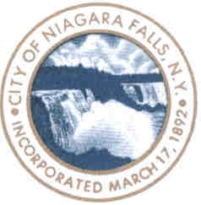
Block Party Application
You must gather a petition signed by 75% of the houses/businesses on the block being closed stating that they are aware of the block party and are in agreement with it. (petition is enclosed in this packet)
- Name of the street closed________________________ Zip code_______
Requested street closing lies between what 2 cross streets:

_____________________ and __________________________
2. Date of the party (street closing)_________________________

3. Time of the party: FROM________am/pm- TO___________am/pm
(Block parties cannot continue past 10:00 pm)
4. Contact Person (required to issue permit)
Name and if applicable Organization: ___________________________
Address___________________________
Phone# ___________________________
Email (optional):____________________
5. Payment of an administrative fee of $25.00 is required to begin
processing your permit request. This fee is non-refundable.

All applications must be submitted 30 days prior to the scheduled date. Failure to do so may result in an inability to process your paperwork and the permit could be denied.
Approval___________________________ Police Department
Approval___________________________ Fire Department
Approval___________________________ Public Works Department
Approval___________________________ City Clerk

Block Party Rules and Regulations
A block party is a community-based event hosted by a group of neighbors,
A non-for-profit organization or an association on a City street requiring
closing of a portion of the street, a single block, for part of a day.

Block party applicants must reside on the street and within the one block
area being closed.

- You must gather a petition signed by 75% of the houses/businesses
On the block stating that they are aware of the block party and are in
agreement with it. (Petition enclosed in this packet)

- No block party shall extend beyond 10.00 pm.

- No public right-of-way shall be completely blocked.

- Access must be available for any person wishing to use the
Right-of way for pedestrian purposes.

- No alcohol shall be sold/consumed at any block party

- Absolutely no stakes are to be driven into the street.

- The permit holder shall be responsible for the removal of all litter
and refuse deposited in the public right-of-way.

- No person attending any block party in the public right-of-way shall make any loud noise or disturbance which will create a nuisance for persons not attending the block party.

Contact Person___________________________________________
Day Phone _________________Evening Phone_________________
The undersigned hereby petition the City of Niagara Falls for a permit to close the
following street________________ between ____________and _____________
For a block party to be held on:
Date:______________________ from _________ am/pm until__________am/pm

By signing below, we, abutting residents affected by the proposed closure, acknowledge notification of the above listed street closure

 | ADDRESS | NAME / SIGNATURE | PHONE
1
2
3
4
5
6
7
8
9
10
11
12
13
14
15

 | ADDRESS | NAME / SIGNATURE | PHONE
16
17
18
19
20
21
22
23
24
25
26
27
28
29
30
31
32
33
34
35
36
37
38
39
40
41
42
43
44
45
46
47
48
49
50

We are hosting a block party!
YOU’RE INVITED!
Here is more information about the party:

We will be closing _________________________(street, ave.)
between ____________________and ____________________
on _____/_____/_____ from _______am/pm to_________am/pm
If you have any questions feel free to contact:

Phone:____________________________
E-mail:____________________________
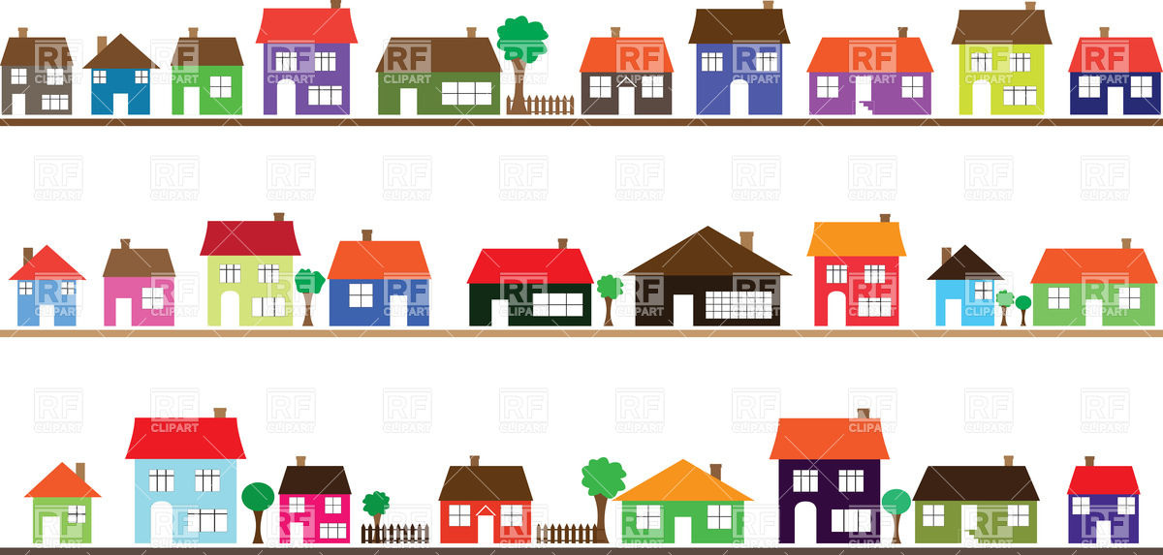
You are required to submit notification to all affected residents regarding your
street closure. You may use the flyer below, or create your own. You must attach
a copy of your notification flyer to your application.

