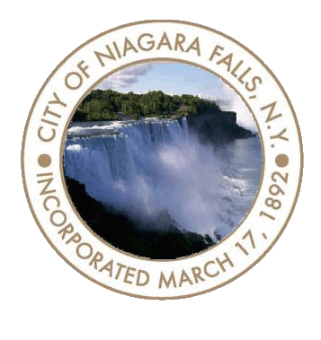
To the Residents of the City of Niagara Falls,

It is my privilege as Mayor to welcome you back to City Hall. Listed below is a list of guidelines to keep everyone safe:

- The public entrance to the building will now be the main entrance on Main Street. Handicap access will be at the ramp entrance off the parking lot and when you arrive, please use the phone mounted there to gain entry.

- Everyone entering the building will be required to wear face mask covering.
- Maintain social distancing of 6 feet.

- If you are coming to City Hall to complete in-person transactions at the Billing & Collections Office or the City Clerk’s Office, you may experience a long wait time as each office will be servicing only 2 customers at one time. You are encouraged when making a payment or submitting documents to do so by mail or online.

- If you have business with any of the other City departments in City Hall, please call the respective department to make an appointment, departments will be operating by appointment only. When arriving for your appointment, please access the ramp entrance off the parking lot. Upon arriving, use the phone that is mounted outside and indicate your name and the department with which you have an appointment. Someone from that department will meet you and bring you to the appropriate location for your appointment.

Mayor Robert M. Restaino

Board and Commission Meetings at City Hall
Listed below is a list of proposed board and commission meetings for 2020:

N.F.C. Development Corporation:
July 22 - Cancelled
September 9
November 23
Contact number: (716) 286-4482

Urban Renewal Agency (URA):

July 22- Cancelled
September 23
December 2

Contact number: (716) 286-4470

Zoning Board of Appeals:

July 21
August 18
September 15
October 20
November 17
December 15

Contact number: (716) 286-4464

Planning Board:

July 22
August- RECESS
September 9
September 23
October 14
October 28
November 25
December 16
December 23

Contact number: (716) 286-4470

