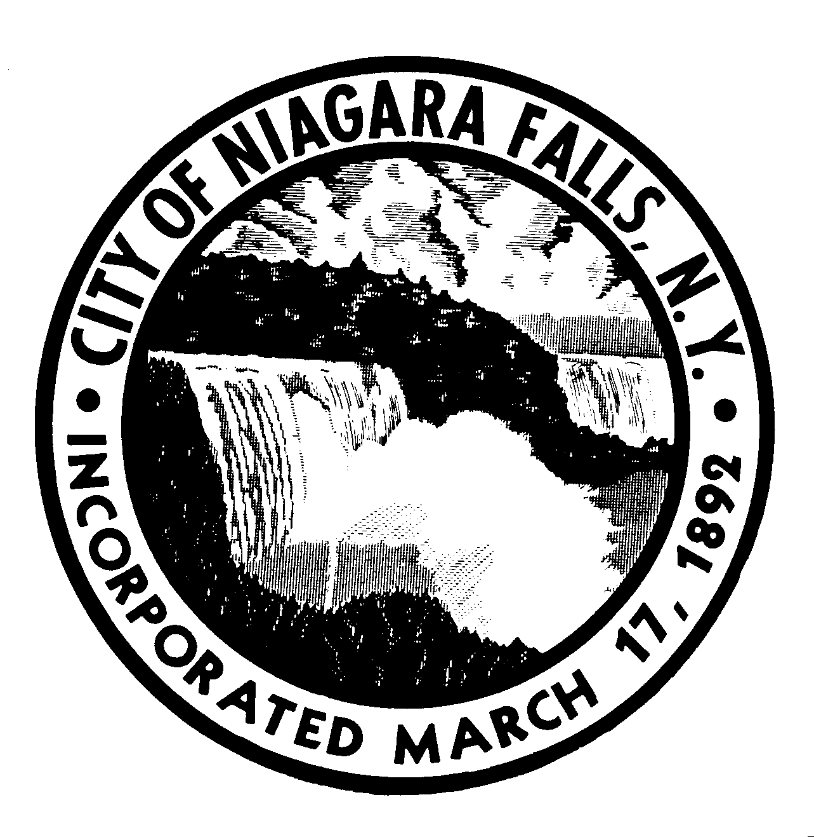
NIAGARA FALLS ZONING BOARD OF APPEALS

CITY OF NIAGARA FALLS, NEW YORK

A hearing of the Niagara Falls Zoning Board of Appeals will be held on Tuesday, January 19, 2016 at 5:30 p.m., in the City Council Chambers, First Floor, City Hall. If you have any questions, please contact the Department of Code Enforcement at 286-4450.

APPLICANT OR REPRESENTATIVE MUST BE PRESENT
U-4009 – Terri Rolling, as applicant for property located 3695 Pine Avenue. The applicant is proposing to open a restaurant in a R1-D zoning district. The restaurant use is not allowed within the R1-D zoning district. Therefore, requesting a use variance to allow the restaurant in the R1-D zoning district.

U-4010 – Anthony Fasciano, as owner of property located at 808 Pine Avenue. The owner is proposing to erect a minor motor vehicle repair shop on a vacant lot located within the C1-A zoning district. Minor motor vehicle repair shops are not allowed within the C1-A zoning district. Therefore, requesting a use variance to allow a minor motor vehicle repair shop in the C1-A zoning district.

A-4011 – Candella Construction, as agent for owner, for property located at 8665 Rivershore Drive. The applicant is proposing to erect an addition to an existing dwelling. The minimum side yard setback on the west side shall be 6’. The applicant proposes a west side yard setback of 5’, therefore, requesting an area variance of 1’ on the west side yard. The minimum front yard setback shall be 30’. The applicant is proposing a front yard setback of 13’-6”, therefore, requesting a front yard area variance of 16’-6”.

Respectfully submitted,

Julie Kunecki
Secretary
Niagara Falls Zoning Board of Appeals

