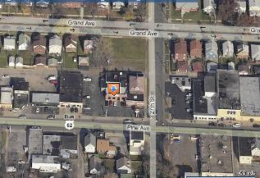
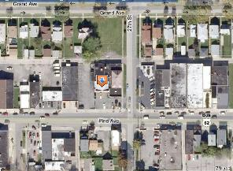

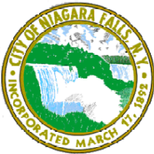
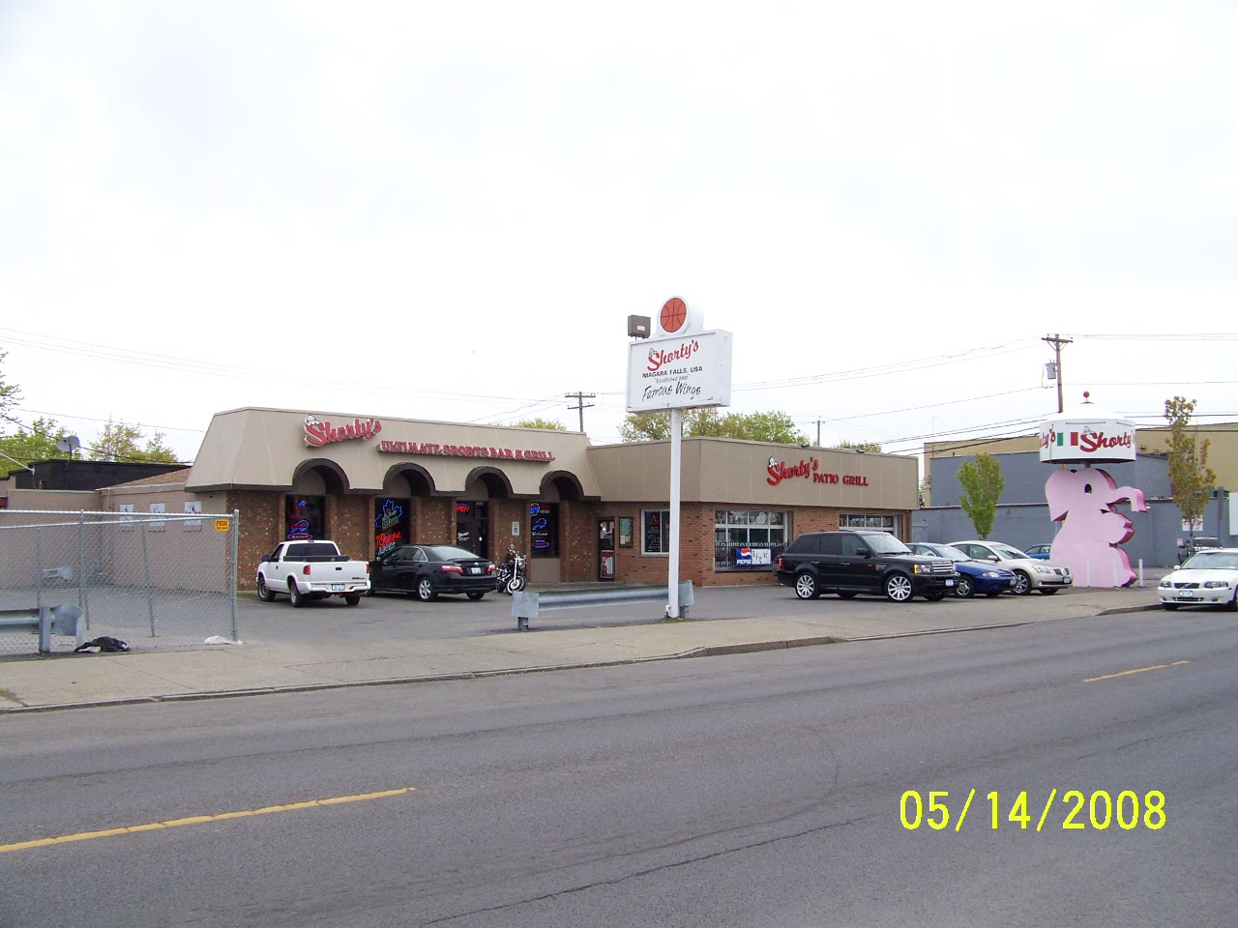
2626 Pine Avenue, Niagara Falls, NY
Owner | Nelson Fasciano, Jr.
Realtor | Andrea DiNieri (716) 579-3662
Asking Price | For Sale - $775,000
Section, Block Lot # | 144.82-2-31
Zoning | C2-B (Commercial – Traditional – Medium Density)
Property Type | Restaurant
Current Use | Restaurant/Bar
Permitted Uses | Bed & Breakfast, Retail Sales & Service, Bar, Restaurant, Office, etc.
Assessed Value for Taxes | $195,700
Lot Size | 85 x 139
Year Structure Built | 1963
Building Square Footage | 11,640 sq.ft.
Rentable Square Footage | 6,062 sq.ft.
Residential Units | n/a
Number of Stories | 1
Comments | Shorty’s Sports Bar & Grill. Located in Little Italy.  Completely remodeled.
 | *For more information on this listing, please contact the realtor
Aerial View
Bird’s Eye View
Street View

