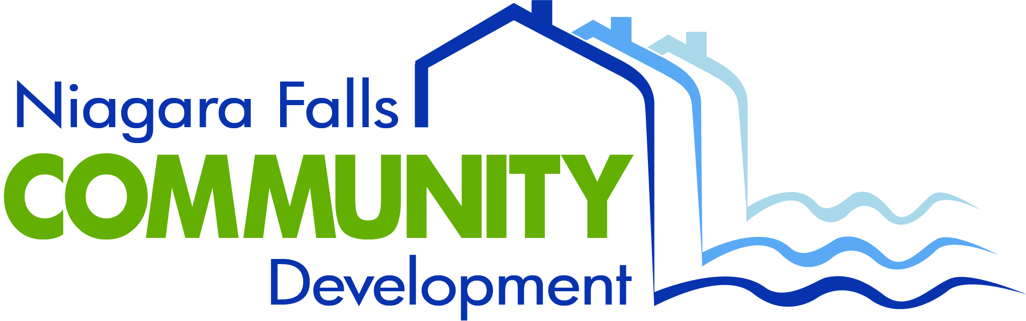

To: Niagara Falls City Council
From: Seth Piccirillo, Director of Community Development
Date: 2/22/18

PURCHASE OF HYDE PARK INCLUSIONARY PLAY EQUIPMENT

It is the administration’s recommendation that Hyde Park Inclusionary Play Project Equipment should be purchased from KOMPAN Playground Equipment, consistent with United States Department of Housing and Urban Development procurement guidelines and the New York State Office of General Services Playground Equipment, and Related Products Statewide Contract. The total amount that the Niagara Falls City Council is being asked to authorize is $113,803.50

The Hyde Park Inclusionary Play Project will not require any municipal general fund or casino capital fund revenue. The community directly voted in favor of the Hyde Park Inclusionary Play Project as part of 2017’s Participatory Budgeting (PB360) Project. The Niagara Falls City Council approved the PB360 Budget as part of the 2017 United States Department of Housing and Urban Development (HUD) Community Development Block Grant (CDBG) Action Plan, including a $75,000 CDBG allocation for this project. The Niagara Falls City School District was recently awarded a $50,000 grant from the John R. Oishei Foundation in support of the capital portion of the Hyde Park Inclusionary Play Project. Both the CDBG and Oishei Foundation funds will be dedicated to the purchase of equipment. Niagara Falls Community Development will allocate competitive New York State Heath Foundation, and Ralph C. Wilson Foundation funds to equipment installation. The entire project is estimated at $220,000, including purchase of equipment.

The Hyde Park Inclusionary Play Project will create a special public space for children of all abilities connected to the existing Hyde Park Playground, constructed in 2016. We asked our residents what they wanted and they told us. NFCD has partnered with the Niagara Falls City School District Committee on Special Education, EMPOWER Niagara, the Niagara Falls Youth Board, Niagara University and Kompan Playgrounds to design an inclusionary play space to exceed ADA compliance. The City of Niagara Falls, like many communities, does not have a specific public space designed for, and by, children with special needs. ADA compliance alone does not send an open invitation for free play to all children, especially those with special behavioral needs.

Hyde Park is the second largest municipal park in NYS and is reachable (walk/bike/public transit) for a majority of Niagara Falls' residential neighborhoods. Four public schools (Niagara Street Elementary, Hyde Park Elementary, Gaskill Preparatory and Niagara Falls High School) and all located within 1 mile, totaling 3,494 students. Currently, 315 PK-12 school district students with an Individual Educational Plan (IEP) receive a motor skills based therapy (physical or occupational) and 432 have a Section 504 Plan that targets behaviors that impacts their learning and attending tasks. Many local students with an IEP are classified as having an intellectual disability, autism, emotional disturbance, or other health impairment, often ADHD. Kompan, and our stakeholders, designed the inclusionary space to directly benefit these groups, while making it an enjoyable free play space for all children. Additionally, students working with learning disabilities, and speech or language impairments will also benefit from having an environment that is specifically designed to promote socialization, and build confidence through equipment that is developmentally appropriate, but varies in the degree of difficulty for all to navigate.

This project is part of CD and the City of Niagara Falls’ continuing effort to increase and improve youth facilities and services in our community.

Will the Council vote to so approve and authorize the Mayor to execute a contract for the purchase this equipment, in a form acceptable to the Corporation Counsel?

__________________________________________
Paul Dyster, Mayor

__________________________________________
Nick Melson, City Administrator

__________________________________________
Seth Piccirillo, Director
Niagara Falls Community Development

___ Kennedy ___ Scott ___ Tompkins ___ Voccio ___ Touma

